YMCA Youth Volunteer Form
Youth’s Name __________________________ Birthdate ____/____/_______
Parent(s) Name _____________________________________________________
Address ______________________________ City/State/Zip _________________
Phone (Home) ___________________________ (Cell) ___________________
Volunteer position you’d like to apply for (Circle all areas of interest):
Custodial Races Special Events
Please write at least one sentence describing the talents and skills you possess that will help you succeed as a YMCA Youth Volunteer: __________________________________________________________________________________________________________________________________________________________
When are you available to volunteer?
Days of the Week: ___________________ Between the hours of _____________
Please read the following statement concerning YMCA Youth Volunteer positions and expectations.
As a youth volunteer you will be under the direct supervisory of a YMCA employee. You will be expected to obey the rules of the YMCA and demonstrate a positive, helpful attitude. You will be required to stay for the duration of any volunteer position once agreed upon by the YMCA Supervisor, your parent(s), and you. The use of any inappropriate language or behavior will result in an immediate dismissal of your volunteer services. The opportunity is a privilege and not to be used as a position of authority to your peers. As a YMCA volunteer, you are to serve the YMCA members and guests with respect at all times. Any volunteer must have volunteer clearances for certain positions.
Clearances required: Criminal, Child Abuse, (FBI may be required for certain volunteer positions). No cost for volunteers.
Visit https://epatch.state.pa.us for Criminal Clearance and www.compass.state.pa.us/cwis/public/home for Child Abuse.
__________________________________________________________________
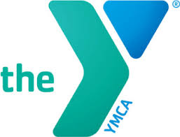
Youth Volunteer Signature Date
__________________________________________________________________
Parent Signature Date

